Empathy Mapping Phase

Empathy mapping helps in understanding the stakeholders involved in the system and their real needs. The goal is to design a solution that is practical, reliable, and user-centric.
2.1 Stakeholders Identified
- Maintenance Engineers
- Plant Operators
- Industrial Managers
- System Designers
2.2 Empathy Map Analysis
What the User Thinks
- Motor failures lead to costly downtime
- Unexpected overheating is difficult to detect early
- Existing monitoring systems are reactive rather than predictive
- Maintenance schedules are often inefficient
What the User Feels
- Concerned about sudden motor breakdowns
- Pressured to maintain continuous production
- Frustrated with false alarms or late warnings
- Need for confidence in monitoring systems

What the User Says
- “We need early warning before the motor overheats.”
- “Unexpected failures increase maintenance costs.”
- “Manual inspection is time-consuming.”
- “We need a reliable and automated solution.”
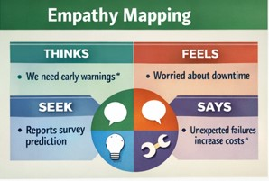

What the User Does
- Performs periodic inspections
- Relies on threshold-based alerts
- Shuts down equipment after faults occur
- Schedules maintenance after damage is detected
2.3 Insights Gained
From the empathy mapping process, the following insights were derived:
- Users need early and accurate temperature prediction
- The system should minimize false alarms
- The solution must be easy to integrate with existing setups
- Predictive insights are more valuable than raw temperature values
These insights guided the system design toward a predictive, automated, and data-driven approach.

